|  |  |  |  |  |  |
| --- | --- | --- | --- | --- | --- |
| Date | 5-Dec-22 | | | Tester Name | Richard Belanger |
| Environment | Penfax - Test | | | Login used | TEST2 |
| Operating System | Windows | Version: | Update: | | |
| Software Used | Edge | Version: | Update: | | |
| Not Applicable | Version: | Update: | | |
| Release version | 22.4.1 | | | | |
| Title | M12.01 Active married member who is not eligible to retire | | | | |
| Test Type | Regression | | | | |
| Test Scenario | Active married member has death calculation processed | | | | |
|  |  | | | | |
| Expected Results | The calculation will be processed and paid to spouse | | | | |
| Pass/Fail | Pass | | | JIRA# | N/A |

Describe your steps with screenshots:

Member is Active, not eligible to retire and passes away

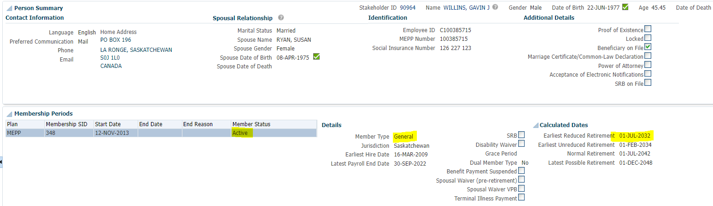

Member terminated due to death

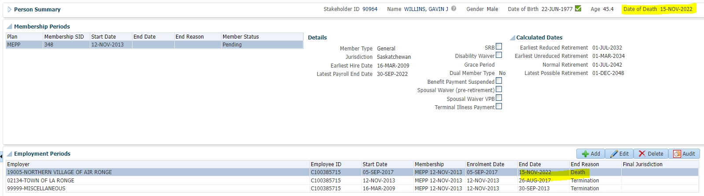

To Benefit Calculation>Calculate

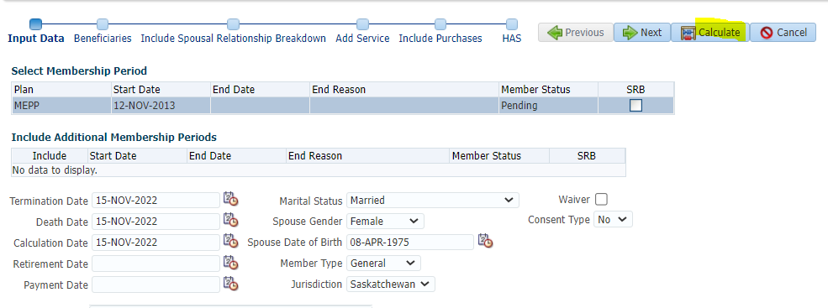

Process

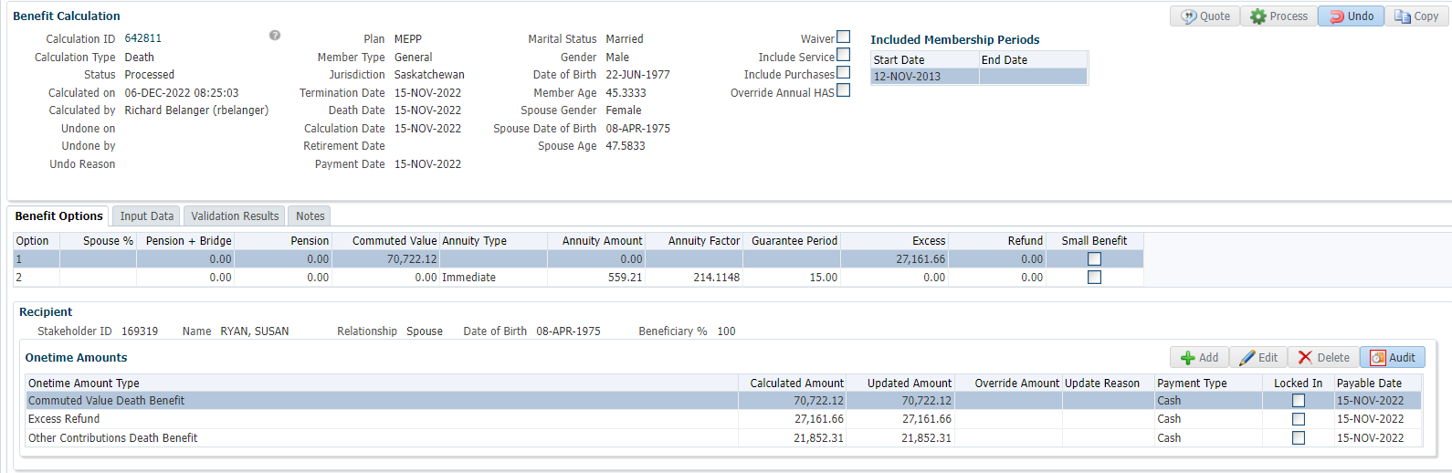

Processed>To Benefit Selection>Next

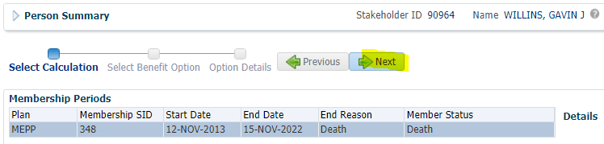

Next

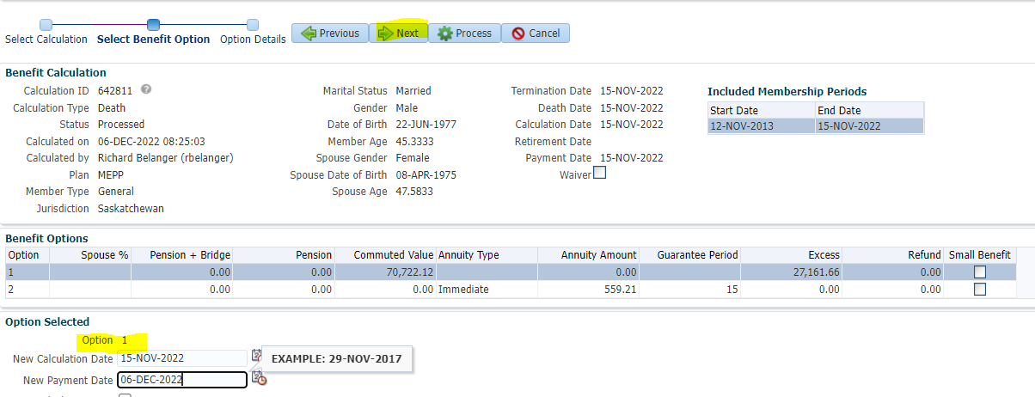

Payment Instructions added; Spouse moving money to RRSP

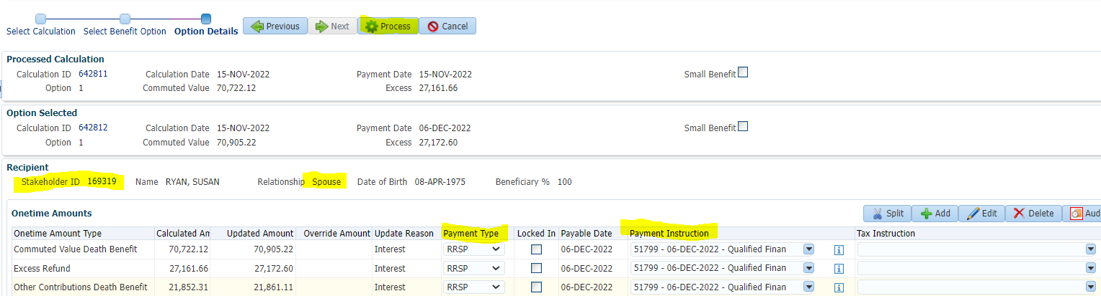

To Benefit Recipient (Spouse)

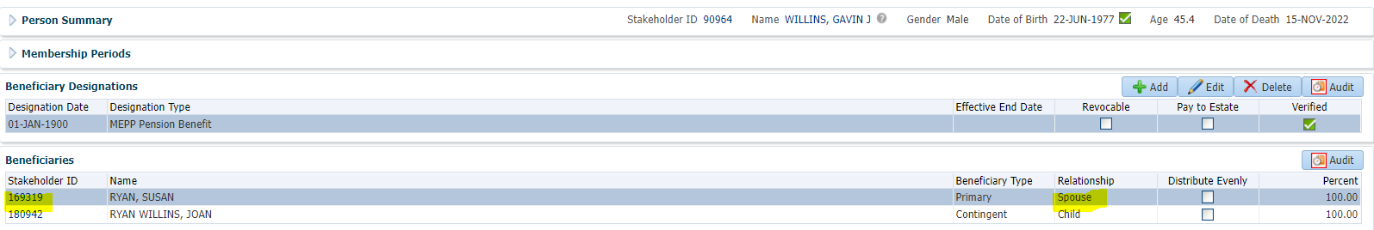

Submit, Approve and Authorize the payment

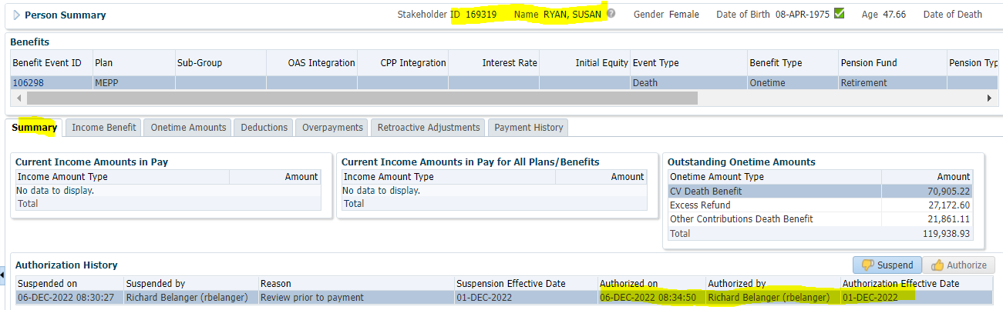

RRSP Death payment made to Spouse

